Day61-63 - Task30 - Terraform(Part-1)

1. Install Terraform on your PC
Download Terraform
Step 1: Open the Terraform official website
Go to: Terraform Installation Page
Step 2: Select Windows
- Download the Terraform package suitable for your Macbook.
- For M1, M2, M3 chip systems, select:
- MacBook, ARM64
- The downloaded file will look similar to: terraform_1
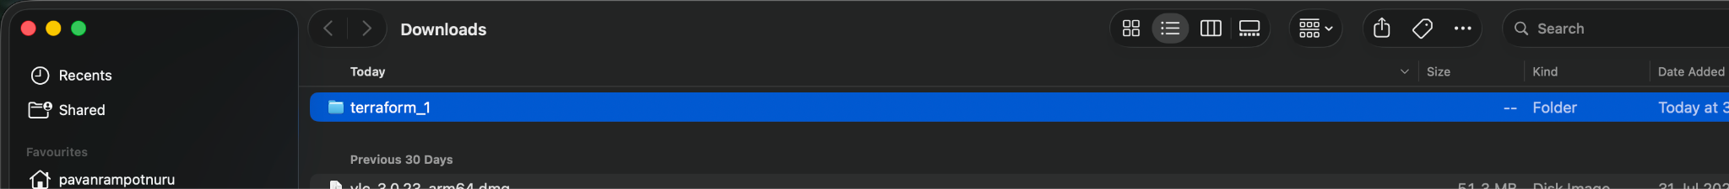
Step 3: Open Terminal and run the following commands,
- sudo cp ~/Downloads/terraform_1/terraform /usr/local/bin/ - run this command to move the single binary file into the local bin path
- Now, give it the permission it needs to run, and tell macOS it is safe to open: sudo chmod +x /usr/local/bin/terraform
- sudo xattr -d com.apple.quarantine /usr/local/bin/terraform

If Terraform is installed correctly, you should see Terraform help information
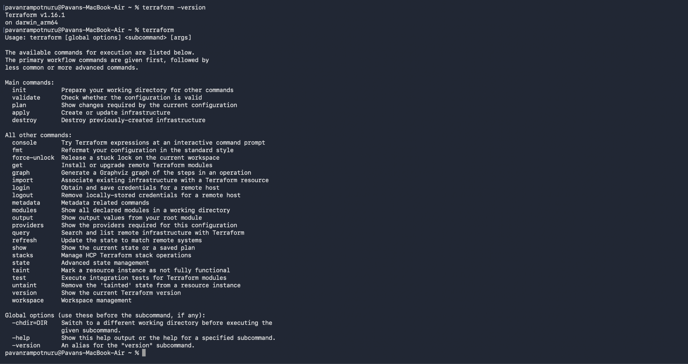
Step 4: Check Terraform Version
- Run: terraform version
- You should get output similar to: Terraform v1.x.x
Step 5: Verify Terraform Location
- You can also run: where terraform
- Expected output: /usr/local/bin/terraform
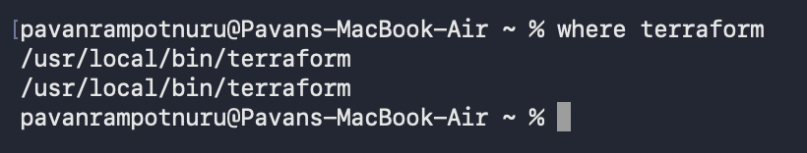
This confirms macOs can find Terraform through PATH.

2. Execute all the templates shown in the video.
Step 1: Create a folder called: Terraform
Step 2: Open VS Code, and open a new Terminal
- Run terraform init
- In the VS Code terminal: terraform init
- This creates the terraform folder structure in the desired path
Step 3: In main.tf , write the below code.
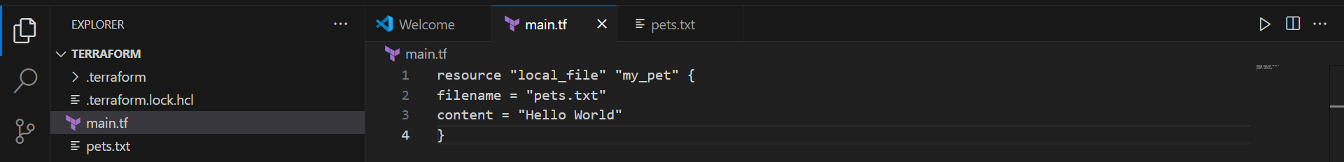
Understand this Terraform code:
- resource "local_file" "my_pet" { - means we are creating a Terraform resource.
- filename = "pets.txt" - Create a file named pets.txt
- content = "Hello World" - Inside the file.
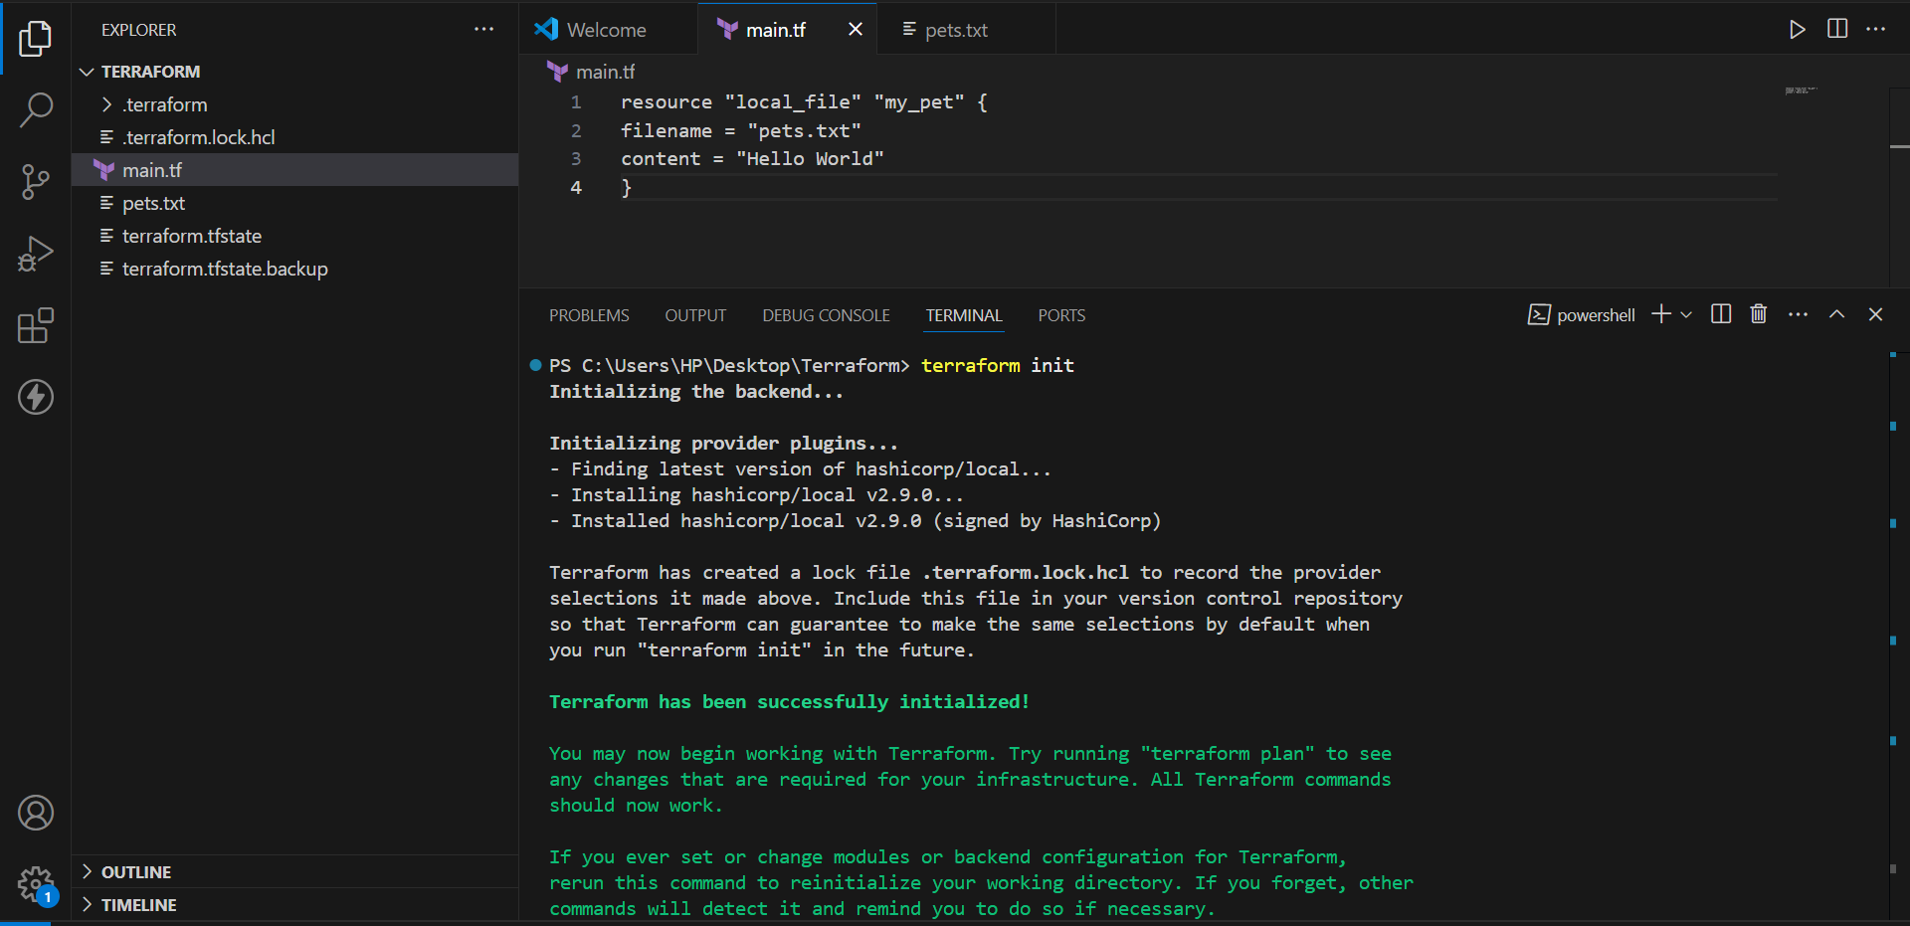
Step 4: Execute terraform plan to know the blueprint of the resources you’re creating with main.tf
- In VS Code Terminal, run: terraform plan
- Terraform will show that it wants to create: local_file.my_pet
- Near the bottom you'll see: Plan: 1 to add, 0 to change, 0 to destroy.
Note: At this point pets.txt has NOT been created yet. The terraform plan only shows what Terraform intends to do.
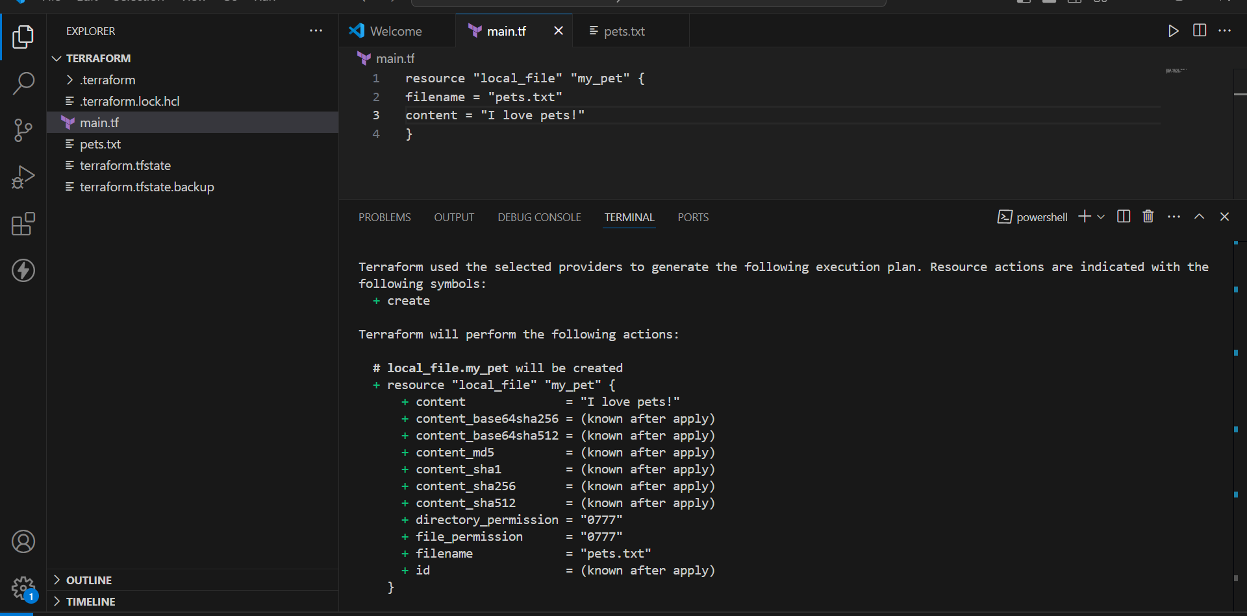
Step 5: Execute terraform apply to create the resources
- In VS Code Terminal, run: terraform apply
- Terraform will show the plan again and then ask:
- Do you want to perform these actions?
- You will see a prompt similar to: Enter a value:
- Type: yes
Terraform will perform the actions described above.
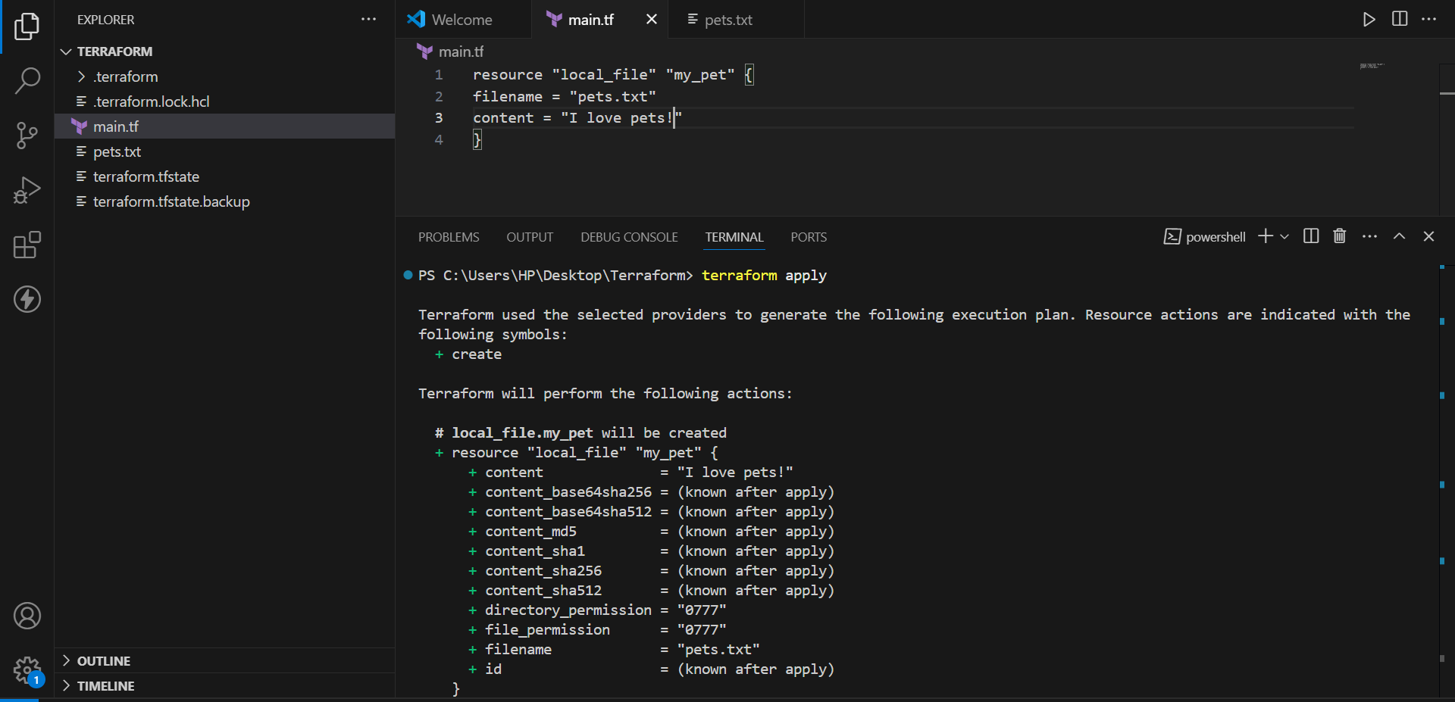
Check the VS Code Explorer
After successful terraform apply, look at the Explorer.
You should now see:
Terraform_basic
│
├── .terraform
├── .terraform.lock.hcl
├── main.tf
├── pets.txt
└── terraform.tfstate
Three important things happened:
main.tf
↓
terraform apply
↓
pets.txt ← created file
terraform.tfstate← Terraform state
Open pets.txt
Click:
pets.txt
inside VS Code Explorer.
You should see:
I love pets!
You can also check from the terminal:
cat pets.txt
Output:
I love pets!
Change the Terraform configuration
Now go back to:
main.tf
Change:
content = "I love pets!"
to:
content = "Hello World"
Your file becomes:
resource "local_file" "my_pet" {
filename = "pets.txt"
content = " Hello World "
}
Save:
Ctrl + S
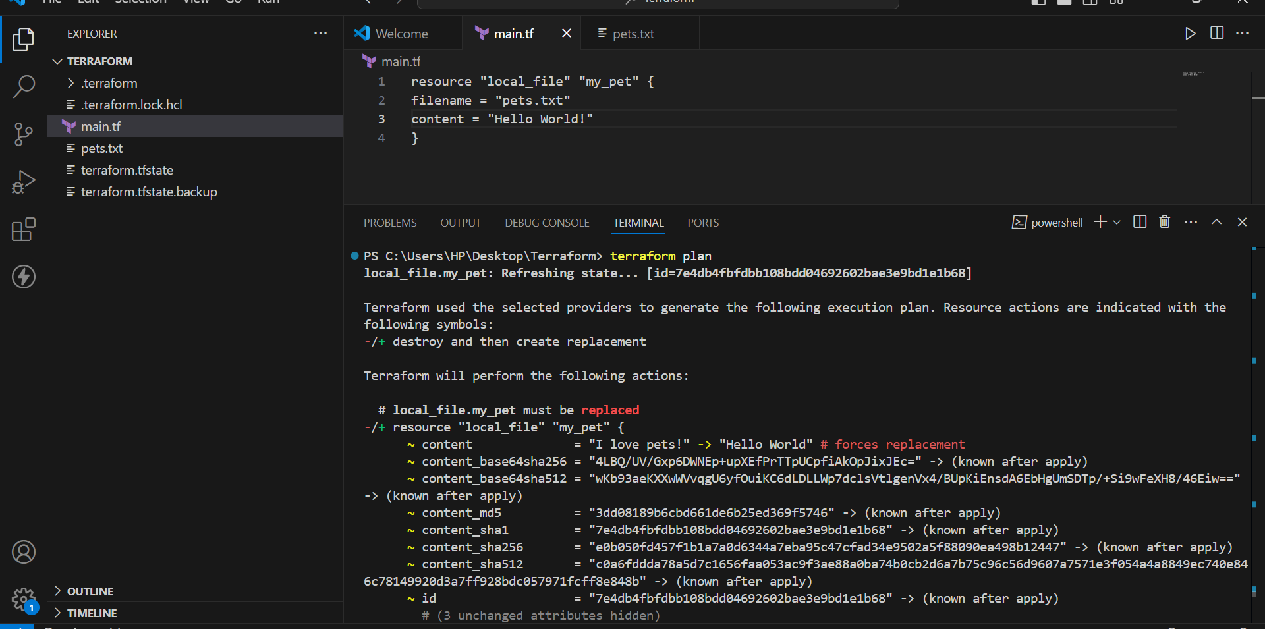
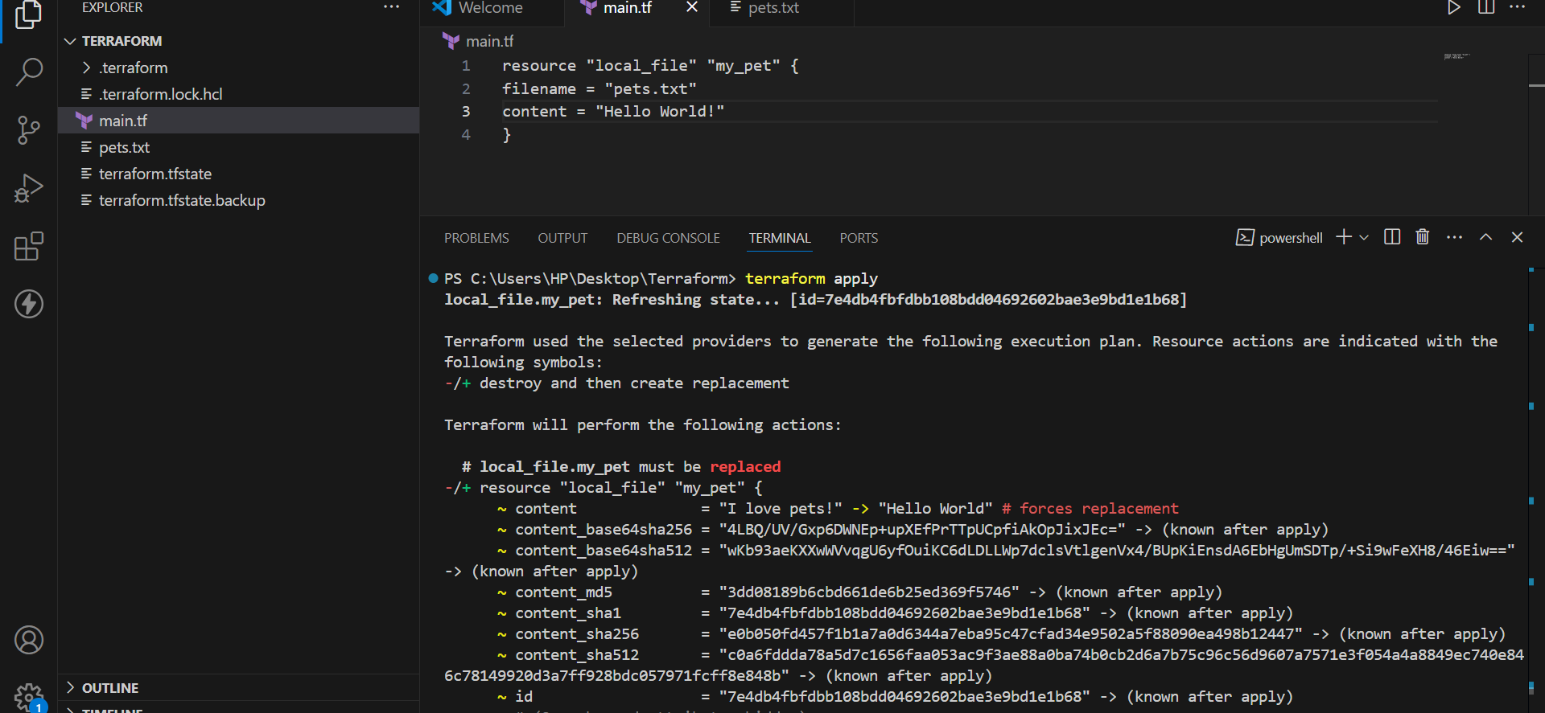
After completion, check:
cat pets.txt
You should get: Hello World!
To see the result:
terraform show
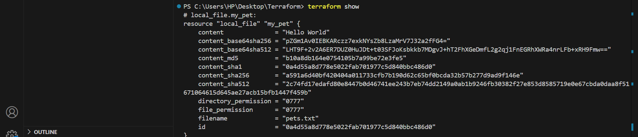
Note down below points, Terraform Init Terraform Plan Terraform Apply Terraform Provide
terraform init
What is terraform init?
terraform init stands for Terraform Initialize.
It is normally the first Terraform command we run after creating a Terraform project.
Command:
terraform init
What does it do?
terraform init:
- Initializes the Terraform working directory.
- Reads the Terraform configuration.
- Identifies required providers.
- Downloads the required provider plugins.
- Downloads required modules.
- Initializes the backend if one is configured.
Example
Suppose we have:
terraform-project/
└── main.tf
Run:
terraform init
Terraform identifies the AWS provider and downloads it.
You may see:
Initializing the backend...
Initializing provider plugins...
Terraform has been successfully initialized!
Simple definition
terraform init initializes the Terraform project and downloads the required providers and modules.
terraform plan
What is terraform plan?
terraform plan is used to preview the changes Terraform will make to the infrastructure.
Command:
terraform plan
It compares:
Terraform Configuration
+
Current Infrastructure/State
↓
Proposed Changes
For example, if your Terraform configuration contains an EC2 resource:
resource "aws_instance" "myserver" {
ami = "ami-xxxxxxxx"
instance_type = "t3.micro"
}
Run:
terraform plan
Terraform may show:
Plan: 1 to add, 0 to change, 0 to destroy.
This means:
1 resource → will be created
0 resources → will be modified
0 resources → will be deleted
terraform apply
What is terraform apply?
terraform apply is used to actually execute the changes defined in the Terraform configuration.
Command:
terraform apply
For example:
terraform plan
shows:
Plan: 1 to add, 0 to change, 0 to destroy.
Then:
terraform apply
will actually create the resource.
Terraform usually asks for confirmation:
Do you want to perform these actions?
Enter:
yes
Terraform then communicates with AWS through the AWS provider and creates the resource.
You may see:
Apply complete! Resources: 1 added, 0 changed, 0 destroyed.
What is a Provider?
A Terraform Provider is a plugin that allows Terraform to communicate with an external platform or service.
Terraform itself does not directly know how to communicate with AWS, Azure, Google Cloud, etc.
The provider acts as a bridge between Terraform and the platform.
Terraform
↓
Provider
↓
Cloud Platform
↓
Resources
For example, if we want to create an AWS EC2 instance:
Terraform
↓
AWS Provider
↓
AWS API
↓
EC2 Instance
Example AWS Provider
terraform {
required_providers {
aws = {
source = "hashicorp/aws"
}
}
}

provider "aws" {
region = "eu-north-1"
}
Here:
provider "aws"
tells Terraform that we are going to use AWS.
region = "eu-north-1"
specifies the AWS region where Terraform will manage resources.

Integrate a sample Terraform template in Jenkins.
Verify Terraform on Jenkins Server
You already did:
terraform --version
and got:
Terraform v1.16.1
on linux_amd64
Now check whether the Jenkins user can use Terraform.
Run:
sudo -u jenkins terraform --version
Expected:
Terraform v1.16.1
on linux_amd64
If you get this, continue.
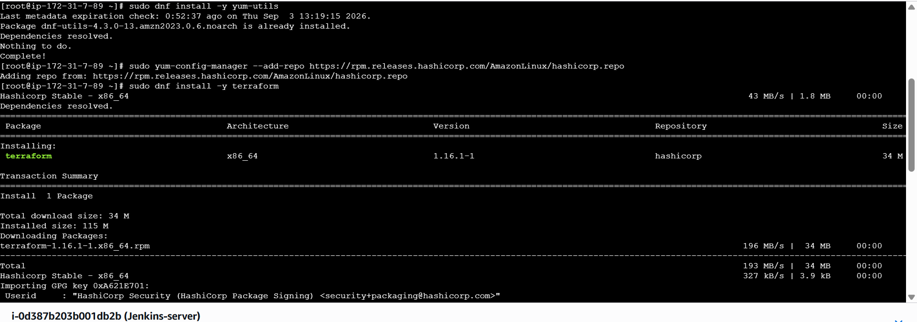
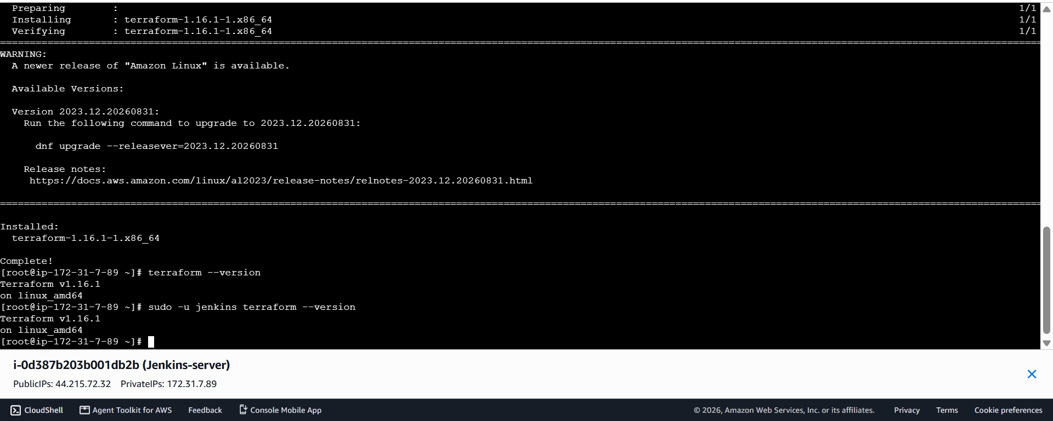
Create Jenkins Job
Open Jenkins in your browser.
For example:
http://<JENKINS-IP>:8080
Then:
Jenkins Dashboard → New Item
Enter:
Terraform-Jenkins
Select:
Pipeline
Click:
OK
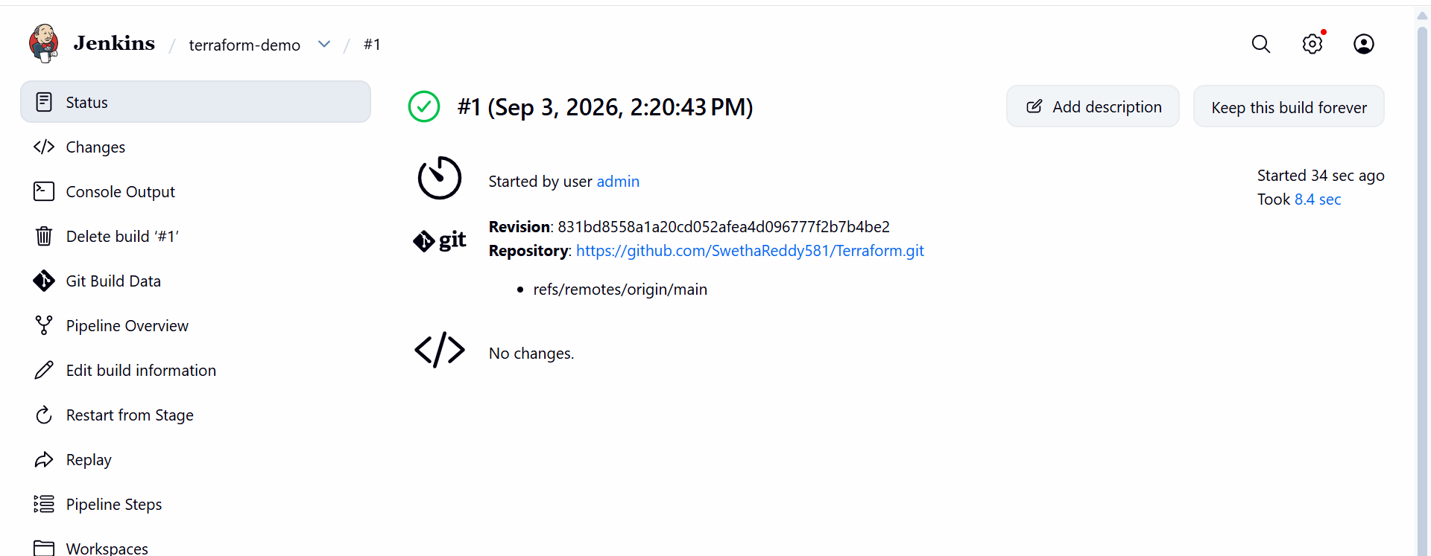

Configure GitHub Repository
Inside the Jenkins job:
Go to:
Source Code Management
Select:
Git
Repository URL:
https://github.com/SwethaReddy581/Terraform.git
Branch:
*/main
So Jenkins knows:
“Whenever this job runs, download the Terraform code from the main branch.”
